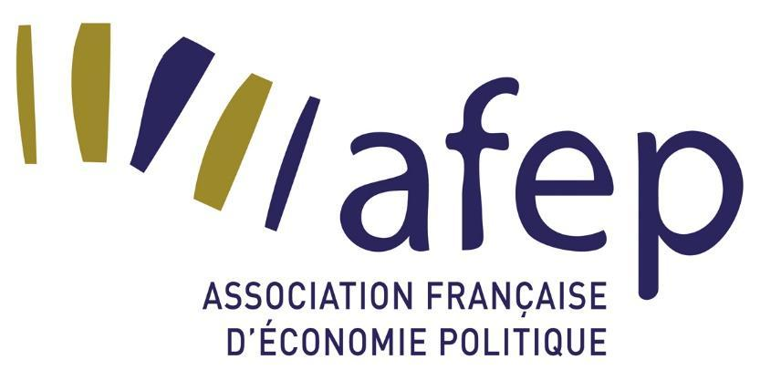

**Call for Papers**

Doctoral Day of the French Association for Political Economy (AFEP)

Sciences Po Bordeaux, June 17, 2025

As in previous editions, the Congress of the French Association for Political Economy will open with a doctoral day organized by and for doctoral students. This day will be a place for meetings and exchanges among doctoral students, an opportunity to discuss the challenges and issues specific to PhDs in social sciences in general and political economy in particular. The day will be organized in two parts: it will begin with a plenary session addressing topics of interest to all doctoral students. This plenary session will be followed by thematic workshops organized around presentations proposed by doctoral students and discussed by more experienced researchers. AFEP is committed to pluralism in economics, as well as to exchanges and collaborations across disciplines, particularly with other social sciences. Therefore, we encourage the participation of doctoral students from disciplines other than political economy, whose work would benefit from dialogue with political economy. The day is also open to Master's students.

The Doctoral Day of the 14th AFEP Congress will take place on Tuesday, June 17, 2025.

**Outline of the Day**

The morning is devoted to the challenges of the PhD and post-PhD career prospects. It begins with a plenary session presenting the academic challenges of the PhD in economics and social sciences.

The afternoon consists of parallel workshops bringing together experienced colleagues and doctoral students around methodological issues or specific themes. The idea is to exchange in small groups based on works previously submitted by doctoral students, which they will present.

**Call for Contributions**

To participate in the afternoon thematic workshops, we invite doctoral students in political economy to submit a communication proposal. We also invite doctoral students in social sciences (economics, history, political science, sociology, etc.) and Master's students interested in opening their research to political economy to present their ongoing work and participate in collective exchanges. Their communication proposals are also welcome. All proposals must be sent to us by **March 15, 2025, at the latest**.

The communication can focus on the thesis project in general, a specific part of the thesis, or ongoing valorization (article, presentation, etc.). *Proposing a communication for the Doctoral Day does not prevent you from also proposing a communication for the general AFEP Congress.*

To form coherent groups and invite discussants closest to your research themes, the call is structured in three phases:

* Submission of a 2-page abstract (with indicative bibliography): by **March 15, 2025**, at the latest. Please specify your university and affiliated laboratory, as well as your year of thesis or the Master's program in which you are enrolled.
* Notification of acceptance of communications: **March 31, 2025.**
* Submission of the complete communication (4 to 10 pages): by **May 15, 2025**, at the latest.

Communication proposals should be sent to the following address: doctorants@assoeconomiepolitique.org

**Organizing Committee:** Bijan Valilou, Lou Delepierre, Julien Guillot